PIPE logic is used as inter-process communication. (Note without using pipe () system call function)

Pipe is for one-way communication, one process writing into the pipe and the other reading from the pipe.

The image below shows more how the communication has been done.

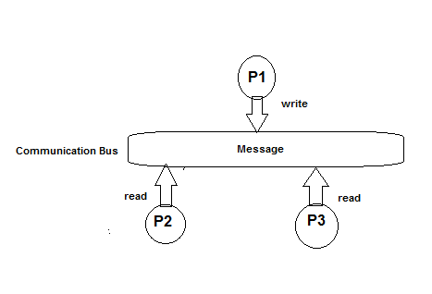

PIPE is used because the communicated processes are local and it is less overhead.